**TRANSPORT TO AND FROM RECOMMENDED HOTELS**

**AIRPORT SERVICE**

* **Collection of delegates from the airport**

During the reception phase, participants will be transferred from the airport to their hotels by zone in the colour-coded groups shown below.

A fleet of vehicles (saloon cars and VIP coaches) will be stationed at the airport; departures will be based on the number of delegates arriving.

* **Return to the airport**

The transport committee will organize participants' transfers from their hotels to Abidjan FHB Airport when they are due to leave Côte d'Ivoire.

This service will be organized according to the departure needs communicated.

Delegate shuttles will be stationed in front of each hotel.

**From 8 to 27 August 2021**

* **Departure times for shuttles from the recommended hotels (see list) to the Congress venue (Sofitel)**

**7.00**

* **Departure times for shuttles from the Congress venue to the recommended hotels**

**18.00**

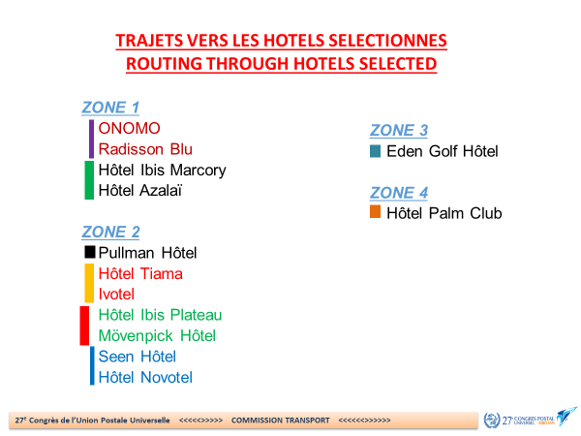

**SHUTTLES**

**Line 1 (blue-green)**

* **Onomo (7.00)**
* **Radisson (7.10)**
* **Ibis Marcory (7.30)**
* **Azalaï (7.45)**
* **SOFITEL HOTEL IVOIRE ABIDJAN CONGRESS VENUE**

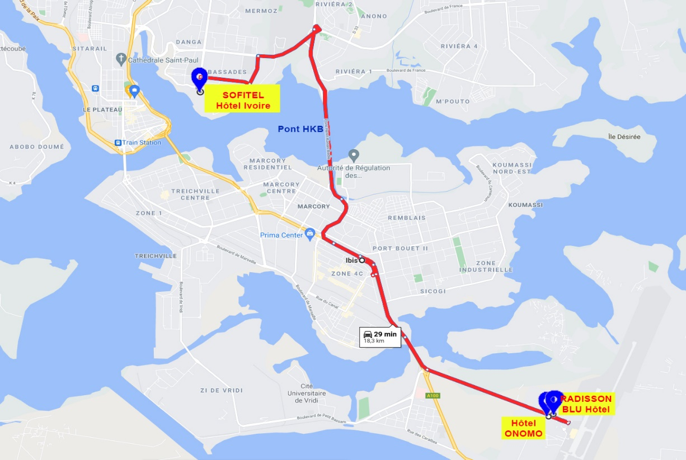

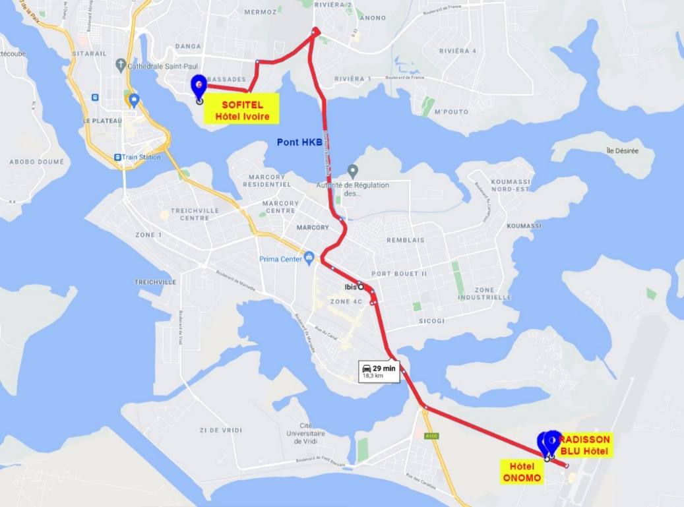

**Line 2 (green line)**

* **Azalaï (7.45)**



* **SOFITEL HOTEL IVOIRE ABIDJAN CONGRESS VENUE**

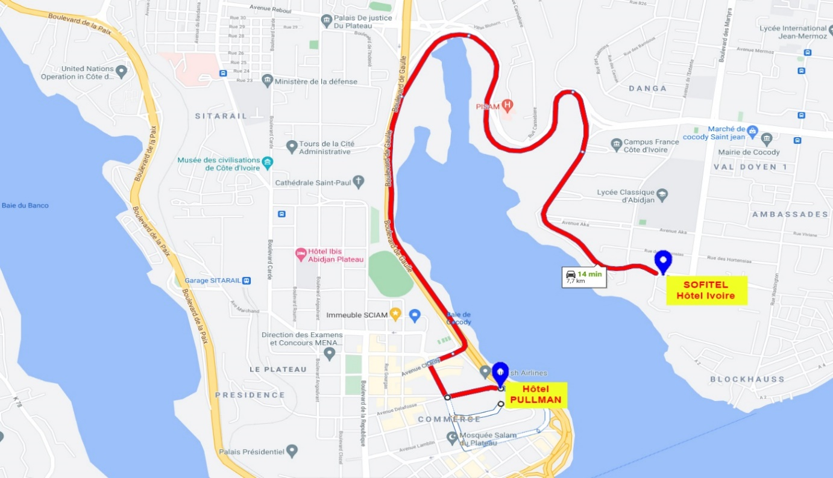

**ZONE 2**

**Line 3: (black line)**

* **Pullman**



* **Sofitel Hôtel Ivoire**

**DEPARTURE FROM**

* Pullman

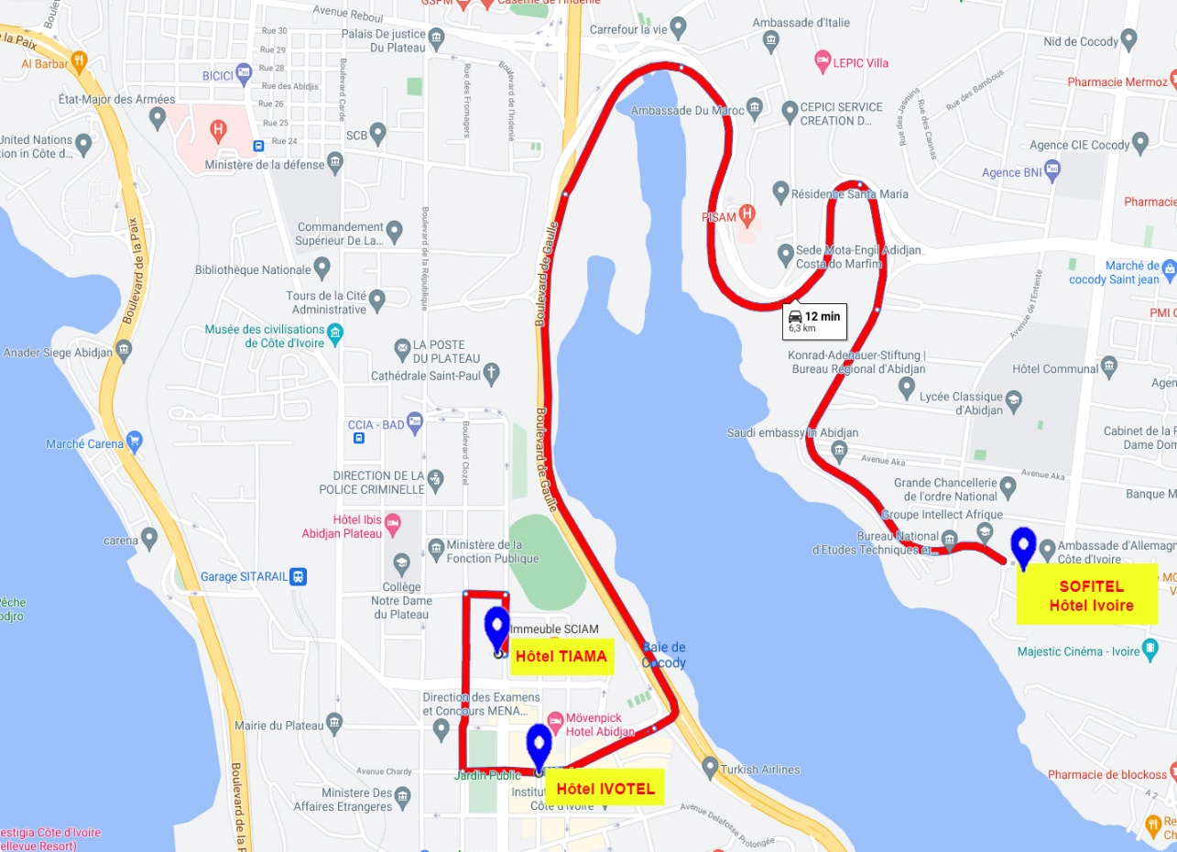

**ZONE 2**

**Line 4: (orange line)**

* **Tiama (7.00)**
* **Ivotel (7.30)**



* **Sofitel Hôtel Ivoire**

**DEPARTURE FROM**

* Tiama

**ZONE 2**

**Ligne/Line 5: (ligne rouge/red line)**

* **Ibis Abidjan Plateau (7.00)**
* **Mövenpick‎ (7.30)**



* **Sofitel Hôtel Ivoire**

**DEPART/DEPARTURE FROM**

* Ibis Plateau

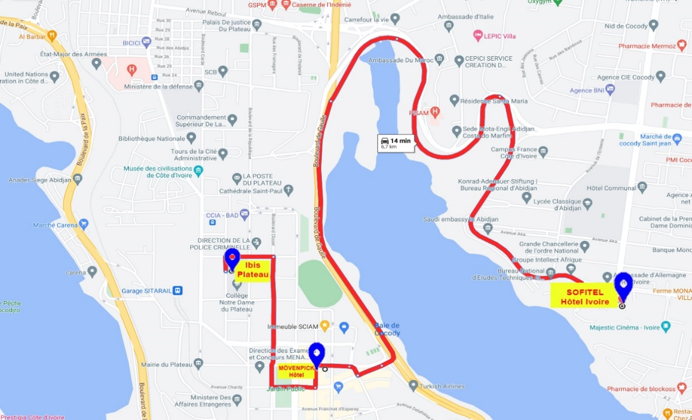

**ZONE 2**

**Line 6: (blue line)**

* **Seen (7.00)**
* **Novotel (7.30)**



* **Sofitel Hôtel Ivoire**

**DEPARTURE FROM**

* Seen

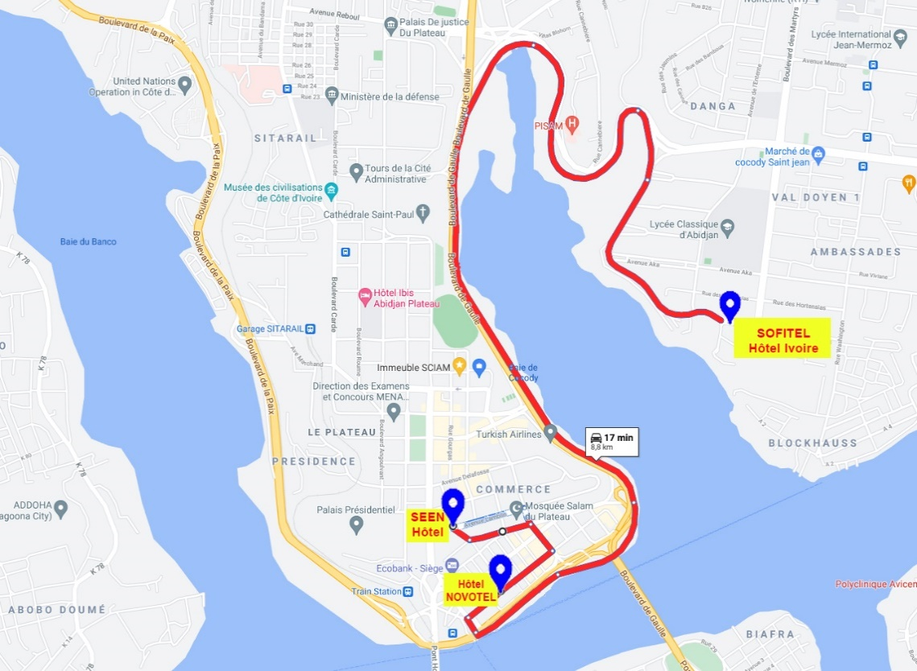

**ZONE 3**

**Line 7: (blue line)**

* **Heden Golf (7.30)**



* **Sofitel Hôtel Ivoire**

**DEPARTURE FROM**

* Heden Golf

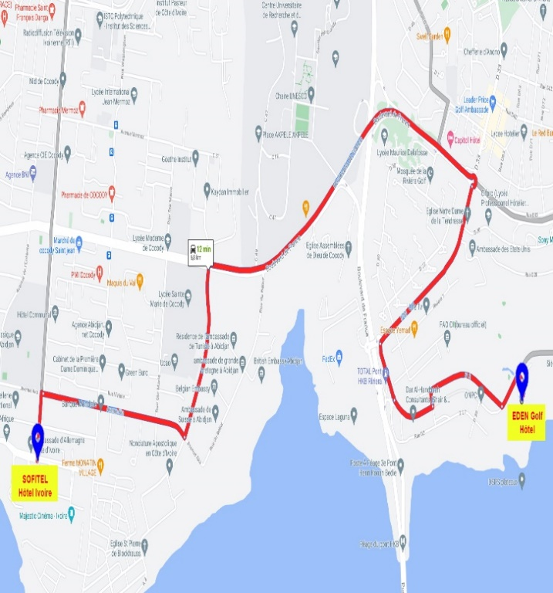

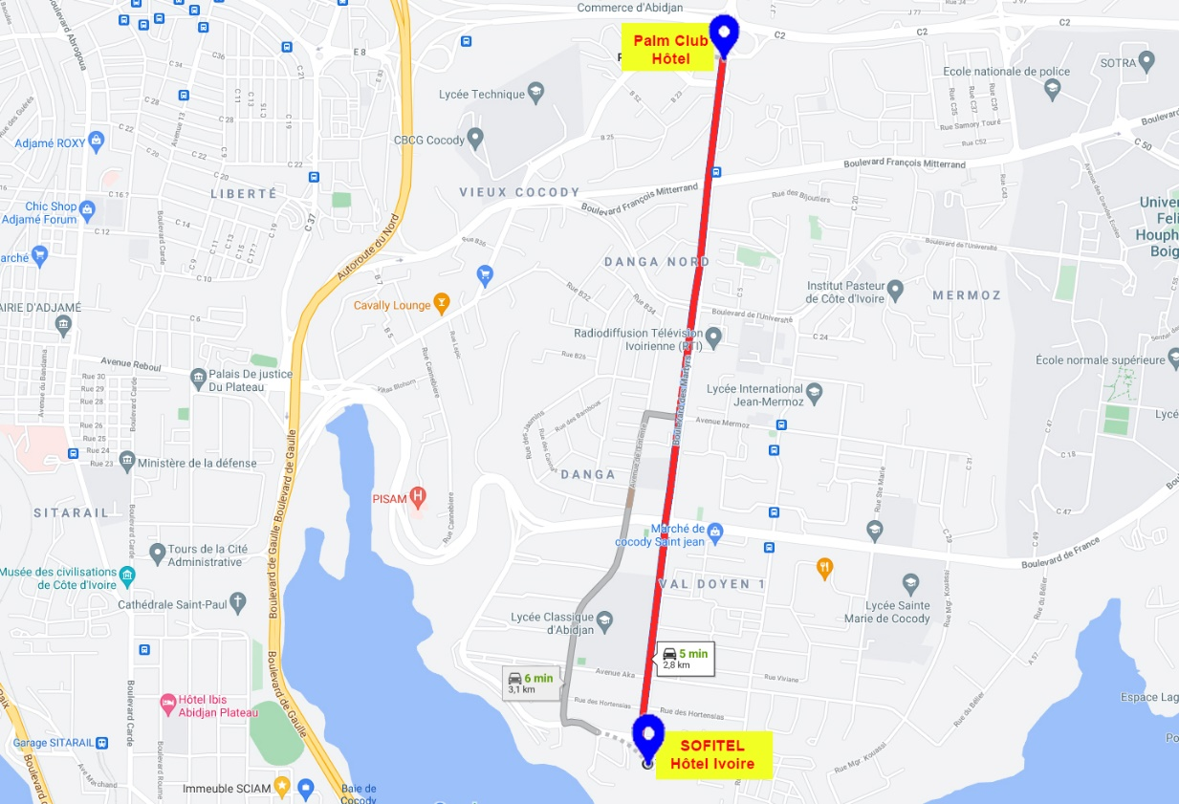

**ZONE 4**

**Line 8: (brown line)**

* **Palm Club (7.30)**



* **Sofitel Hôtel Ivoire**

**DEPARTURE FROM**

* Palm Club

**PRIVATE TRAVEL AROUND THE CITY**

For participants' private travel needs, a group of rental companies has been identified:

|  |  |  |  |  |
| --- | --- | --- | --- | --- |
|  | **NAME** | **TYPE OF RENTAL** | **MEANS OF ACCESS** | **CONTACTS** |
| *1* | **TAXIJET** | Taxi | Telephone call  Mobile application | +225 07 08 72 59 87 |
| *2* | **YANGO** | Taxi | Mobile application |  |
| *3* | **ROADSTAR** | Daily rental | Telephone call | +225 01 01 05 04 04  +225 01 03 11 71 71 |
| *4* | **AVIS** | Daily rental | Telephone call | +225 07 89 90 82 80  +225 27 21 23 97 21 |

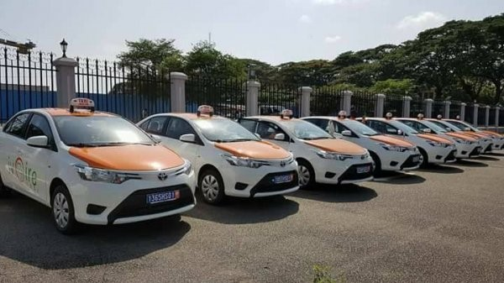

**Line 4:**

**Tiama – Ivotel**

**>>>>>>> Sofitel**

**Outward**

* Tiama
* Ivotel