GRS Requirements – Overview

Preamble
This document focuses mainly on features to be provided to users from DOs of UPU member countries. It also covers interfaces, from a functional point of view, but does not cover management functionalities that are required for UPU staff, or regional features.
It does not provide technical information.
It does not mention anything about data volumes, but it is important to keep in mind that data volumes are large. This can be considered big-data, even if the requirement is to keep “only” 13 months online, with associated challenges for storage and performance, especially because of the diversified types of sorting and calculations required.

Table of Contents
1 Overview 4
2 Report areas and cockpits 4
3 Measurements 4
3.1 General approach 4
3.2 Common display features 5
3.3 Data quality 5
3.3.1 Transmission timeliness 5
3.3.2 Transmission issues 5
3.3.3 Ratios 5
3.3.4 Compliance 6
3.4 Service information 7
3.4.1 Volumes 7
3.5 Service performance 7
3.6 E-certification 8
4 Transversal features 9
4.1 Tracking 9
4.2 Reporting hub for standard reports 9
4.3 Alerts 10
5 Management of service information and standards of designated operators 11
6 Main interfaces 12
6.1 EDI data feed 12
6.2 UPU code lists and other reference data 12
6.3 EDI compliance 13

Overview
GRS is a web secured platform (login required) providing reports to posts on international mail they exchange with partner posts. The reports are based on electronic information exchanged among posts.
GRS focuses on reports for identified mail (mail with tracking data).
The general approach is top-down, with some overview information visible first, then the possibility to “zoom” into details. Shortcuts are also provided, to go directly to details in any area.
The look-and-feel of GRS is inspired by an existing platform providing reports for EMS (express mail service), called EMS SMART and giving full satisfaction to the user community. With this approach, user training is expected to be minimal.
The general screen layout is provided in section 4 of the main document listing requirements. This layout is important. This document also mentions that GRS must run on tablets and smartphones. The tablets and smartphones should adapt the proposed layout herein which takes priority: normal users of the reporting system use a computer, not a smartphone. We want these normal users to have a nice and functional solution.
Many different types of users are expected to use GRS. Typically, users will connect to GRS to:
- Check for any quality issue with the data exchanged
- Check how their post performs in terms of quality of service, to ensure they do not get penalized
- Investigate any issue related to the above
- Follow and analyze trends (volumes, performance…)
Related requirements: UPU-754

Report areas and cockpits
In GRS, information is organized by area. At functional level, the following areas are defined:
- Data quality
- Service information
- Service performance
With the top-to-bottom organization, cockpits are displayed per area upon selection of an area by user. A cockpit provides a quick overview of major indicators/measurements of the area, preferably in a graphical view. A cockpit also gives the possibility to zoom-in on a specific measurement, to get more details. A cockpit is the entry point for checking and investigating potential issues in an area, with the top-to-bottom approach.
Related requirements: UPU-550, 556

Measurements

General approach
Unless specified otherwise, measurements are provided separately for identified letters and for parcels.
For letters, measurements are primarily provided for items containing goods, identified with prefix L.
Other measurements for the below item types of letters should be measured:
- Registered (prefix R)
- Insured (prefix V)
- Small packets (prefix U), where applicable.
Related requirements: UPU-001

Common display features
As indicated in its name, the main purpose of GRS is to display reports, either as aggregates or item level.
Reports are displayed primarily as tables. The system must include the possibility to export the contents of any table displayed on screen, as text and spreadsheet.
It must also be possible to display information as a graph instead of table.
Another key feature is the possibility to select a cell and drill-down. This is not necessarily on all columns or lines in a table; it is based on logic, with the idea that user must be able to analyze results and understand when something is wrong.
Related requirements: UPU-553, 554, 555, 600, 601, 602

Data quality

Transmission timeliness
GRS must provide information on EDI messages transmitted in time or not, with the possibility to drill-down to details. The time limit for transmitting messages depends on the message and product. The UPU will provide the thresholds.
Related requirements: UPU-210, 460

Transmission issues
GRS must inform user in case of EDI transmission issues, via a functionality in the system.
This may also generate an alert (see the corresponding section for alerts)
A transmission issue is when a DO stops sending a certain message, or to a certain partner.
Related requirements: UPU-013

Ratios
Ratios consist in comparing different mail tracking events. They are very important to check the quality of data exchanged. For example, what is the percentage of mail bags scanned as received compared to mail bags sent by partners? (this would be the ratio RESDES over PREDES,). Or what is the percentage of items marked as delivered compared to items that arrived in the country? (ratio delivery over EMD). Etc.
See annex 7 for information on EDI messages (PREDES, RESDES, EMSEVT, etc.) and tracking events (EMA, EMB, etc.).
Most ratios are at item level, plus a few at receptacle level.
The following, among other, ratios must be calculated and made available, per DO and product, with a daily, weekly and monthly view:
- Outbound events:
  - EMA over EMB
  - EMA over EMC
  - EMB over EMA
  - EMB over EMC
  - EXC over EXA
  - EMC over EMA
  - EMC over EMD
- Outbound receptacles and transport:
  - CARDIT over PREDES
  - PRECON over PREDES
  - RESDIT 74 over CARDIT 47
  - RESDIT 74+21 over CARDIT 47
  - RESDIT 21 over RESCON

- Transit:
  - EMK over EMJ
  - EMJ over EMK
- Inbound tracking:
  - EMD over EMC
  - EMF over EMD
  - EMD over delivery (first of EMH, EDH, EMI)
  - Delivery (first of EMH, EDH, EMI) over EMD
  - EMH over actual delivery (first of EDH, EMI)
  - EMH over EDH and EMI
  - EDH over EMD
  - EDC over EDB
- Inbound receptacles:
  - RESDES over PREDES
  - RESDES over RESCON
  - RESCON over PRECON
  - RESCON over RESDIT 21
For each ratio, user must be able to drill-down and list the mail objects that do not meet the criteria.
For the display of ratios, it is suggested to put in place a visual approach possibly combining all ratios or at least grouping them, to facilitate understanding and convenience.
This visual display should enable the display of percentages or volumes, for present or missing items. Typically a view of volumes for missing items shows how many items do not meet the required ratio. For example, for ratio “EMA over EMB”, if the number showed is “9”, it means that there are 9 items with EMB but not EMA. Drill down is provided and lists the 9 items.
For indication, in the EMS SMART solution, all ratios are displayed in a single screen, with possibilities of adjusting the information displayed. Here is the aspect of the screen, for indication:
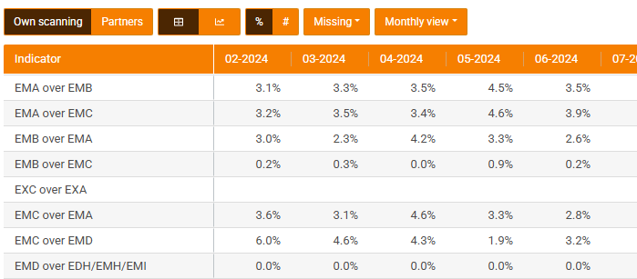
Related requirements: not listed in annex 6

Compliance
Today detailed compliance checks are performed in a dedicated system and associated database.
The development of compliance measurements is detailed in annex 6b.
With a modular approach, annex 6b might be developed in a future phase of GRS. In that case, in the initial phase of GRS, an interface needs to be established to inject the compliance results from the system in place. Calculated compliance data will be made available in the GRS for aggregating and/or reporting the compliance KPIs. The UPU will provide a list of all compliance KPIs required to be reported in the GRS.
Related requirements: UPU-216, UPU-217

Service information

Volumes
The report shows the volume of mail items sent or received, by partner DO, in the chosen period. Drill-down is provided to list the items, with a link to the tracking feature.
The system also provides volumes of receptacles and dispatches sent/received per mail subclass.
Related requirements: UPU-460

Service performance
Service performance consists in measuring the duration (also called elapsed/transit time) of each segment of the process.
At a high level, the following elapsed/transit times must be measured:
- Leg 1-Origin segment (EMA to EMC)
- Leg 2-Cross-border segment including International Transportation (EMC to RESCON)
- Leg 3-Destination segment (RESCON to delivery [first of EMH, EDH, EMI])
For each of these 3 basic measurements, sub-stretches are also measured, as long as data is available, to facilitate analysis, as follows (the list below is not exhaustive):
- Leg 1:
  - EMA to EMC
  - EMA to EMB
  - EXA to EXC
  - EXC to EMC
- Leg 2:
  - EMC to (first of RESCON/RESDES/EMD)
  - EMC to PREDES
  - PREDES to PRECON
  - PRECON to CARDIT
- Leg 3:
  - First of RESCON/RESDES/EMD to delivery (first of EMH, EDH, EMI)
  - EDB to EDC
  - EMD to EMF
  - EMF to EDD
  - EDD to EMG
  - EMG to EDG
  - EDG to delivery (first of EMH, EDH, EMI)
Origin and Destination segments can be displayed with the same aspect. International Transport segment (in Leg 2) is more complex and must be displayed differently.

For each of these elapsed/transit times, user chooses the type of measurement:
- Raw/elapsed times
- Transit Times in working days
- On-Time performance (Transit Times against service standard)
The system must provide drill-down and must display anomalies.
The trend is very important, so the system must show the evolution over time.
For indication only, here is the aspect in the EMS SMART system for On-Time performance showing the percentage delay at 1, 2, 3 and above 3 days:
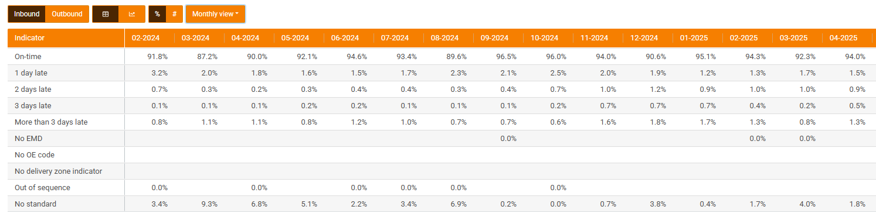

For service performance, display of information in traditional tables (as shown above) is required, but another more visual display must also be provided. This module will be key for the usability success of GRS.
Request ID UPU-1200 gives an idea of possible additional details, with additional measurements: the Leg 1 (sometimes referred to as export leg) can be divided into several segments, and similarly the Leg 3 (sometimes referred to as import/delivery leg). The display should handle this in a clear, visual manner, with the possibility to zoom in and out.
If a DO has several offices of exchange, possibility must be given to see the performance per office separately.
Transport performance depends on the destination. The amount of data also varies significantly depending on the transport type used (receipt or not of RESDIT messages from airline) and destination. A solution must be proposed to display useful information clearly.
End-to-end performance is a combination of all the above. It is shown from Origin perspective by default but it can also be shown from the destination perspective.
With this feature, the GRS should allow each DO to check their performance and associated evolution, and also to see precisely where weaknesses are. The UPU will provide a list of all service performance KPIs required as standard reports in the GRS.
Related requirements: UPU-450, 451, 452, 453, 454, 455, 456, 457
UPU-351, 352, 353, 354, 355, 356, 357, 358, 359
UPU-1200

E-certification
E-certification stands for electronic certification. It corresponds to a certification of DOs on quality of service.
GRS will not cover the formal certification process but will provide all required quality results.
For e-certification, a number of indicators must be combined in order to obtain a score.
Most of the indicators will be in the GRS for other purposes already.
GRS must provide the score, calculation rules, associated indicators, with possibility to drill-down on each indicator.
GRS will also provide ranking of DOs for the score, so that each DO can compare their results with others.
Related requirements: UPU-1300

Transversal features

Tracking
The tracking feature consists in displaying all information on a specific chosen mail object, combining and displaying nicely the associated information sent over time in different electronic messages.
Typically, for a mail item, the tracking information will display its lifetime from the first event (posting) in the origin country to the final delivery in the destination country, with all intermediate events, including events associated to the mail bag in which the item is transported. It should be mentioned that not all items will have posting and delivery events. Some items will miss these events but tracking should be made possible for any item even those with only one event.
Tracking must be possible on the 4 types of mail objects: mail item, receptacle, dispatch and consignment.
It is key to have a very clear (user friendly) and complete tracking module.
To save project time and cost, it must be envisaged to copy the tracking module from the existing platform EMS SMART mentioned in the overview section, as this existing module provides full satisfaction (specifications or source code should be made available for bidder to “copy”).
Here is the aspect of tracking on a mail item in EMS SMART (columns providing details are purposedly hidden but would display information):
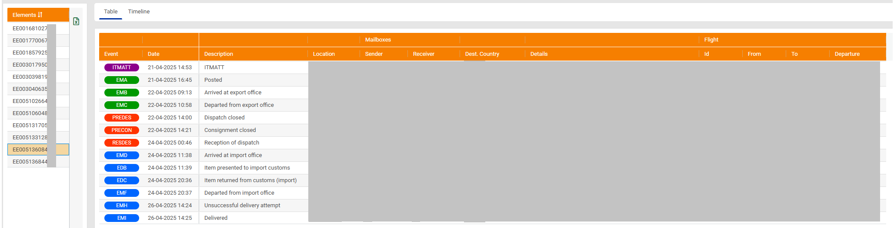

Related requirements: UPU-1000, 1001, 1002, 1003, 1004 and 1005

Reporting hub for standard reports
The solution will include a section to provide pre-calculated reports in a static format: PDF or Excel.
This approach gives extra flexibility to the solution, with the possibility to put in place specific reports for a certain DO and to publish official reports or even reports generated from other systems, outside GRS.
The feature is already in place in the EMS SMART solution. It provides two entry levels, with a separation between DO specific reports and global reports available to all.
Here is the aspect of the global reports (the aspect for DO specific reports is exactly the same, but different reports are provided and security is handled differently so that each DO sees only reports for their own DO):
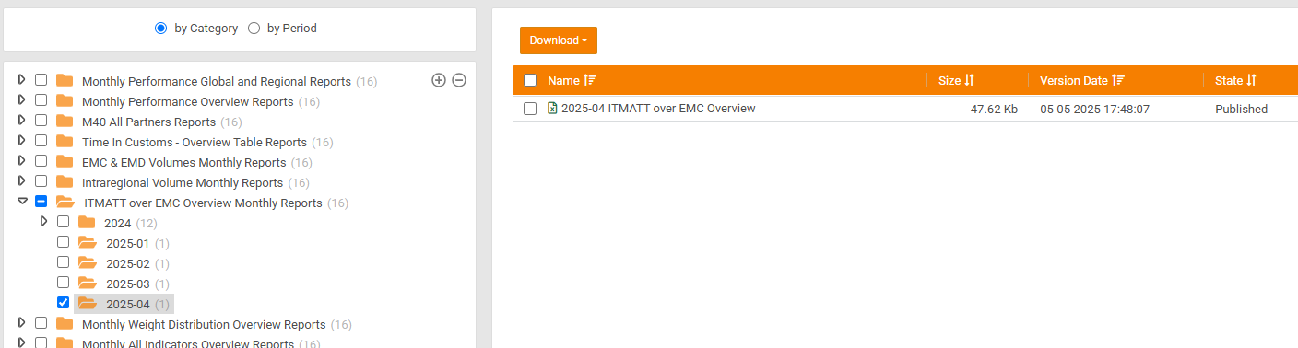
It is requested to put in place a similar approach and display, with maximum flexibility: when a new type of report is published, it is added to the tree-list menu.
This will be used for the publication of reports generated from pre-existing solutions:
- UPU parcel (and ECOMPRO??) reports
- UPU letter reports for Registered (R), Insured (V) and Tracked (L)
It will also be used for the publication of new reports.
Related requirements: UPU-150, 151, 152, 153, 154, 155 and 156
UPU-500, UPU-501, 511, 512, 513, 514, 515
UPU-650, 651, 653, 654, 655, 656, 657, 658, 659, 660

Alerts
A sophisticated alert mechanism is required.
An alert consists in an automatic email sent to users belonging to a DO.
Each user can decide what alerts they want to receive, via a configuration screen.
Such configuration screen is in place in EMS SMART and is giving full satisfaction. It is proposed to copy it or at least take inspiration from it (specifications or source code should be made available for bidder to “copy”).
Here is the aspect of the alert management screen in EMS SMART:
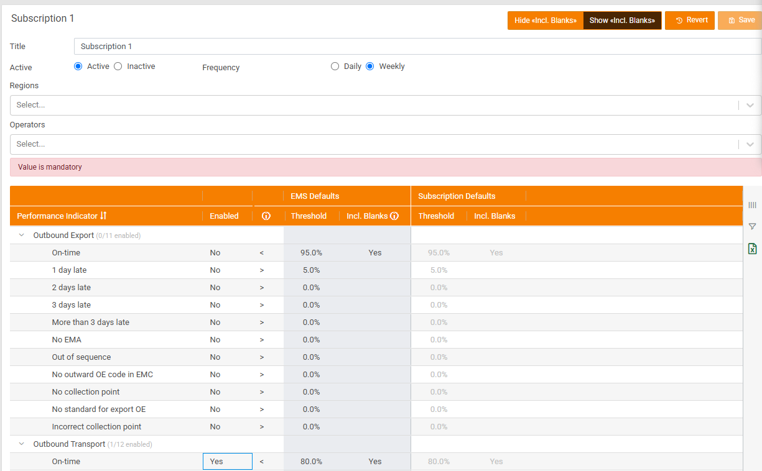
A mechanism is also provided so that the UPU can distribute email alerts to GRS users.
Related requirements: UPU-800, 801, 802, 803, 804, 805, 806, 807, 808, 809, 810
UPU-811, 812

Management of service information and standards of DOs
A separate module must be put in place for DOs to insert and maintain key information used in the GRS.
This reference data consists of the following information:
- Working week days, possibly per product
- Public holidays, both at national and possibly regional level (region within the country)
- Service standards, in days, separately per mail product (at least letters and parcels):
  - Delivery standards: normal duration of inbound process (from inbound receipt to delivery), per destination postcode/range of postcodes/area
  - Export standards: normal duration of outbound process (from posting to dispatching abroad)
  - Transport standards: normal transport time, per destination country
Separate security must be put in place to access the module. There must be different types of access so that some users are able to maintain data while others are only able to view it.
Ideally, the possibility to import data in a specified spreadsheet format should be provided: posts may already maintain this information for other purposes.
The possibility to export data in a spreadsheet format should also be provided.
Important: there is no requirement to migrate data from an existing system.
For details on service standards, please see Annex 2-Validation of service standards
Data will be valid per year. GRS will indicate if data is complete and consistent.
An important aspect of this module is that it will be linked to the calculation of service times (see 3.5 Service performance). It is therefore crucial that all required information for calculations, such as cut-off times, can be entered in this module.
Typically, the maintenance of regional public holiday may require to link some postcode ranges to a public holiday.
In case information is missing for a DO, default values will be used.
Here is a fictitious example, to illustrate the usage of the information maintained in this module:
An international parcel arrives in Switzerland on Wednesday 28 May 2025 at 6pm, is sent to customs on 30-May, released after 2 hours, then is delivered at the UPU (postcode 3015) on Monday 2-June.
The mail is delivered 5 days after its arrival in Switzerland, but the following must be taken into account (fictitious service information for Switzerland):
- Working days are Monday to Saturday
- Thursday 29-May is national public holiday
We must therefore remove 2 days from the delivery time: the public holiday and Sunday. We now have a delivery in 3 days.
Let us also imagine that the delivery standard for parcels in Switzerland, for postcode 3015 is 2 days, but with a cut-off time at arrival at 4pm. This means that if the mail arrives in the country later than 4pm, it is considered to have arrived the next day.
Time spent at customs must also be removed. In our example, it is only 2 hours, so we can ignore it to simplify.
The parcel arrives at 6pm in Switzerland, after the cut-off time, so we must deduct one day from its delivery time. So, we have a delivery in 2 days. This parcel is considered to be delivered on time based on the defined delivery standard.
Related requirements: UPU-861, 863

Main interfaces

EDI data feed
GRS will receive EDI data continuously. The exact approach for the data feed will depend if the EDI compliance module is included or not.
Details are provided in a separate annex.
Related requirements: UPU-001, 002, 003, 004, 005, 006, 007, 008, 009, 010, 011, 012, 013, 014 and 015, UPU-100, 101, 102, 103 and 104

UPU code lists and other reference data
The UPU maintains and publishes code lists. A few of these code lists need to be updated in the GRS regularly because they change over time: typically, the list of DOs with code and name (CL 211), the list of international mail processing facilities (IMPCs, CL 108), the list of EDI addresses (CL 160) and a few others.
GRS must ensure that following an update of reference data, there is no incoherence (such as invalid dates).
It may be necessary to also import and update regularly a few additional code lists from other sources but already available at the UPU: ISO country codes and names, IATA airline codes and names, etc.
As a nice-to-have feature, a functionality may be provided to view EDI addresses and IMPCs
Related requirements: UPU-157, UPU-850, 851, 852, 853, 855, 856, 857, 858, 859, UPU-1050

EDI compliance
Verification of EDI compliance, i.e., compliance of EDI messages exchanged with the technical standards (such as EMSEVT, PREDES, etc.), is vital for GRS. A description of the requirements is provided in annex 3-4b.
A dedicated solution owned by the UPU is currently in place for EDI compliance measurements. The re-development of the EDI compliance measurements as described in annex 3b needs to be done progressively in the GRS in a modular way. Initially, there may be the need to import pre-calculated compliance data (from the existing solution) into GRS so that the GRS can collated, aggregate and report the data in the desired format.
Related requirements: UPU-105, 106 and 107, UPU-1150

