Annex 12

Quality of Service Fund (QSF)

Project application form

Common Fund Project – QSF CFP

Project title: XXXXXXX

To support and enhance the capacity of UPU designated operators to develop inbound and outbound international mail, provide integrated e-commerce services, and ensure quality of service in the postal supply chain network.

Scope:
Global
Regional
Domestic

Target mail flows:
Inward international mail items
Outward international mail items

This project will enhance postal capabilities in the following area(s):
Quality of service
Mail processing and handling
GMS
Counter automation
Mail delivery
Supply chain and security
Security
IT security
Transport
Customs
Postcode and addressing systems
Accounting operational processes
Communication technologies
Other (please specify):

The International Bureau of the Universal Postal Union (UPU IB):

No. | Participating designated operator | TD group classification | No. | Participating designated operator | TD group classification
1 |  |  | 21
2 |  |  | 22
3 |  |  | 23
4 |  |  | 24
5 |  |  | 25
6 |  |  | 26
7 |  |  | 27
8 |  |  | 28
9 |  |  | 29
10 |  |  | 30
11 |  |  | 31
12 |  |  | 32
13 |  |  | 33
14 |  |  | 34
15 |  |  | 35
16 |  |  | 36
17 |  |  | 37
18 |  |  | 38
19 |  |  | 39
20 |  |  | 40

Requested amount from QSF Common Fund budget (in USD)

Designated operators’ own contribution, if any
(in USD)

Total budget (in USD)

Planned duration of the project (in months)

Place: Berne | Date:
Director General of the IB | QSF Global Coordinator
Name: | Name:
Signature: | Signature:

1 Current situation

i Preliminary assessment of the situation: the following should be provided as annexes to this document:
a Project prioritization matrix (PPM)
b Report of ORE review for each country
c National roadmap/country action plan
ii Environment surrounding the proposed global project:
– Political:
– Operational:
– Technical:
iii Need for the proposed global project:
Example:
– Without XXXX, the Post will:
– With XXXX, the Post will:
- XXX
- XXX
iv Advantages for participating designated operators:
– XXX
– XXX
v Advantages for other entities participating in this project (other than Posts):
Example:
– Without XXXX, customs/border authorities will:
– With XXXX, customs/border authorities will:
- XXX
- XXX

2 Aims, objectives and expected results

Aim: To improve operational efficiency, develop e-commerce, and increase the interoperability of network infrastructure – Link to the impact of the project
Objectives: No more than three high-level objectives:
Example:
– Enables DO to:
- XXX
- XXX
– Finalizes the functionality of XXX with:
- XXX
- XXX
– Builds capacity of DOs to:
- XXX
- XXX
Results:

Projects related to QSF CFP (if applicable)

Quality performance indicators (2 or 3 KPIs should suffice)
Proposed quality of service indicators | Current level of performance for each of these indicators | Level(s) of performance targeted, after first year (phase 1) of project implementation | Level(s) of performance targeted, after second year (phase 2) of project implementation | Level(s) of performance targeted on completion for each of these indicators | Objectives to be met by the following date(s) | Monitoring method(s) envisaged
1
2

3 Methodology

Description of the approach

Example:
- The primary objectives of the project are to set up, within the participating designated operator,
- The project will involve some software and IT development issues, which

Project execution mechanism

Example:

The implementation approach for the project is envisaged to be as follows:
- Implementation work and phases:

Phase 1 – Assessment/feasibility study (IB/country)
- Deliverable situation report and improvement plan
- Eligibility (to be able to participate, countries must fulfil the following criteria)
- Method (IB approach)
- Phase 1 validation of implementation approach (audit before new phases)

Phase 2 – Execution of the implementation plan
- Implementation of phase 2/production
- Validation of phase 2 deliverables
- Payment against deliverables

Phase 3 – Monitoring
- Monitor results against KPIs
- Follow up, evaluate, adjust and improve
- Payment against deliverables

Description of tasks and work plans

Example:
Operational | Technical
Preparation (period XXX to period XXX)
– Plan for project and staffing
Analysis (month xxx to month xxx)
– Classify DOs according to readiness and divide into work groups | – Conduct surveys of DOs’ current usage and IT capabilities  - Begin technical development
– Refine project plan with workshop planning | – Plan workshop participation
Execution (per region)
– Develop workshops
– Establish what needs to be produced following the first workshop | – Analyze need for specifics
– Establish what needs to be done by participating DOs | – Identify necessary equipment  – Purchase and deliver equipment
– Establish what needs to be done by participating entities other than DOs | – Perform implementation
– Prepare workshop trainer | – Perform user training  – Perform IT staff training  – Add specification if requested by country (through country’s own contribution)
Review cycle (on site in each country, if possible)
– Audit: review process updates and enhanced service | – Review the use of
– Review results achieved so far | – Provide additional training if necessary
– Formulate additional measures for improvement | – Introduce improvement measures or additional interfaces/specification if necessary

Reports to be submitted for each milestone
Example:
The following results are expected:
– Operational:
- XXX
- XXX
– Technical:
- XXX
- XXX
Dependencies/interfaces:
Example:
This project is an important part, for example, of the UPU ECOMPRO Programme to enhance the capability of DOs to offer
With any operator being able to with other and with , it is possible for DOs to
Description of project control
To ensure a phase-gate approach for better control of project milestones and release of funds (i.e. payment scheme by QSF)
Example:
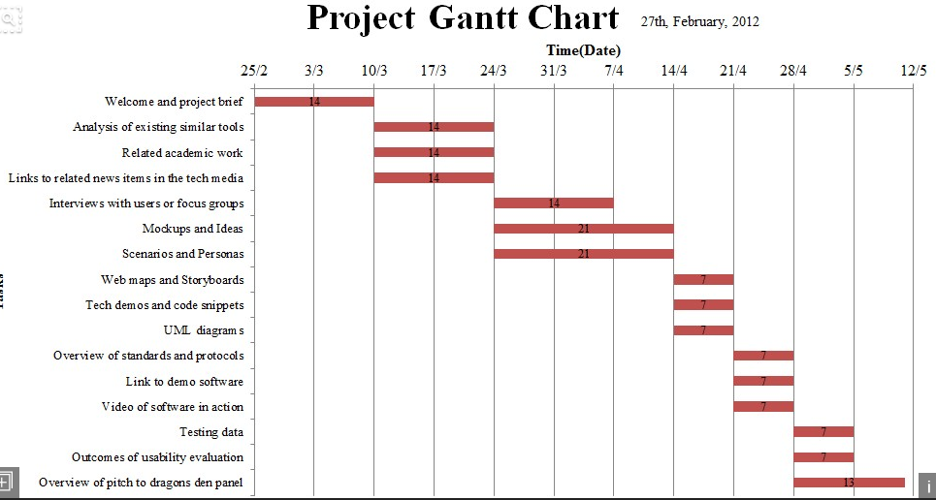

Project team, including the responsibilities of each team member (include the organization chart, if possible)
To include: Project Champion, Project Leader, Project Manager(s), and the entire project implementation team
a The project steering committee is to be considered as Project Champion, comprising high-level management at the UPU IB and acting with Coordinators, QSF National Coordinators in participating countries, and high-level management in participating countries to ensure that the project is progressing according to strategy and to assists the project team.

The project steering committee consists of the following members:
Name | Title | Organization | E-mail

b The project management team is to be considered as the project leader, and comprises the Project Manager and Leader (e.g. from UPU IB/Postal Technology Centre (PTC)) and project management team from the participating countries.
The UPU/IB project management team will develop and manage the project plan, ensuring that schedule, budget, scope and quality are balanced appropriately against what has been outlined in the project plan. General responsibilities include:
- XXX

The UPU IB project management team consists of the following members:
Name | Title | Organization | E-mail

The participating counties’ project management team is provided in Annex XXX.

c The project operations team, comprised of staff from participating countries and staff from the PTC/UPU IB, will ensure that project deliverables are set according to the project plan and schedule. General responsibilities include:
- XXX

Project operations team members are provided in Annex XXXX.

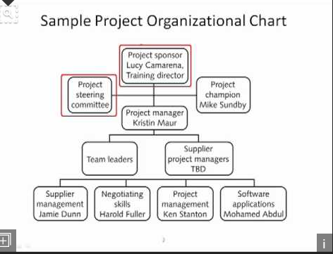
4 Financial proposal

4.1 Budget

4.1.1 Cost summary

 | Cost element | QSF amount (in USD) | DO’s own contribution of additional specification added as per request
A | Labour
B | Services
C | Equipment and vehicles
D | Workshops
E | Others
Total

4.1.2 Cost breakdown

A. Labour (only if project team members are hired exclusively for the project and under strict conditions. (includes daily subsistence allowance (DSA) and travel costs)

No. | Function (specify function) | Person months (P/M) | P/M rate  (in USD) | QSF CF amount  (in USD)
1
2
3
4
5
Total

B. Services

No. | Cost element | QSF CF amount  (in USD)
1 | Independent consulting company: consulting fees
2 | Independent consulting company: allowances
3 | Independent consulting company: travel costs

C. Equipment

No. | Item (specify the equipment or vehicles) | Units | Price per unit  (in USD) | QSF CF amount  (in USD) | Participating designated operator | DO’s own contribution if additional equipment needed
1
2
3
4
5
Total

D. Workshops
(Provide details of workshop: DSA for participants including the project implementation team’s participation, travel costs for every participant, cost of venue and supporting equipment for workshop, cost of interpretation, and any other cost associated with the workshop.)

No. | Cost element (specify the workshop/training course) | QSF CF amount  (in USD)
1
2
3
4
5
Total

E. Others

No. | Cost element (specify the cost element) | QSF CF amount  (in USD) | Participating designated operator | DO’s own contribution if additional elements needed
1
2
3
4
5
Total

The project team will consist of persons, as follows:

No. | Function | Employer
 |  | UPU International Bureau | Consulting company | Participating designated operator staff
1
2
3
4
5
6
7

5 Risk assessment

Risk category | Risk | Control action
Staff-related
Financial
Managerial
Political
Operational (technical implementation)
Environmental

CFP Global Coordinator
Address
Tel.
E-mail

